School of Digital Media & Infocomm Technology (DMIT)
ST1010 Applications Development
Practical 5
Database Access

Objectives:
After completing this lab, you should be able to:
- Write programs to connect to SQL Server.

1.
- Create a new Windows Forms Application project and add a new class called Person. The class consists of the following:

- 3 fields (instance variables) called m_name of type string, m_age of type int, and m_gender of type char.
- A default constructor to initialize m_name, m_age and m_gender to “unknown”, 0, and ‘M’ respectively.
- A parameterized constructor (overloaded) to initialize all the 3 fields using the value passed in.
- 3 properties to provide access to all field values.
- A method called GetYearOfBirth() that computes and returns the year of birth of a person (based on his/her age).

- Create a new class called PersonCollection, which consists of the following members:

- 2 fields (instance variables), which are
- an array of type Person, called Persons, and
- an int instance variable called current, to keep track of the index number of the Person object in the Persons[] array that is currently being viewed.
- A default constructor that consists of the following codes:
public PersonCollection() {
current = 0;
persons = new Person[8]; //can store 8 Person objects
persons[0] = new Person("Mr A", 20, 'M');
persons[1] = new Person("Mr B", 30, 'M');
persons[2] = new Person("Miss C", 25, 'F');
persons[3] = new Person("Mrs D", 19, 'F');
persons[4] = new Person("Mr E", 45, 'M');
persons[5] = new Person("Mr F", 22, 'M');
persons[6] = new Person("Ms G", 76, 'F');
persons[7] = new Person("Miss H", 66, 'F');
}

- A method called, getCurrectPerson() that does not take in any arguments and return the Person object in the persons[] array stored at current position.
- A method called, getTotalNoOfPersons() that simply returns the length of the persons[] array.
- A property for current instance variable.
- Open Form1.cs and design the following UI:
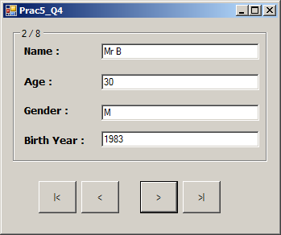
txtName
txtAge
txtGender
txtBirthYr
grpPerson
btnFirst
btnNext
btnLast
btnPrevious

Provide all necessary event handlers, methods and C# codes to make this program work as follows:
- When the form starts, the details of the Person object stored in the persons[] array (in PersonCollection class) are displayed.
- The user must be able to navigate through all the 8 records in the persons[] array.
- The record position should be displayed as text property of the Groupbox.

2.
Modify the constructor of the PersonCollection class (created in Q1) so that the program retrieves data from the following database tables (i.e. load person data from the tblPerson table and put them into persons[] array) :

tblPerson
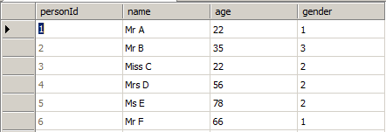

tblGender
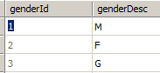

3. Modify the PersonCollection class to use List<Person> instead to store the Person objects persons instead of array. Refactor and separate the C# database connectivity code into a DBPerson class.

- END -

